**CSC20 Project 4 PhoneBook Sp2021**

For this project our aim is to create a phone book with contact details. Individual contact information is added to the contact class. Then these contacts are added to the Phone books array list.

In a phone book the contacts are arranged in ascending order of first name or last name. Hence we will sort our phone book first by “first name” and then by “last name” using sorting algorithms.

Searching contacts is done alphabetically using non-recursive binary search.

**Steps to Follow**

1. Create a class **Contact.java** use to create individual contacts. The class structure is as follows,

class Contact{

public String firstName;

public String lastName;

public long homeNumber;

public long officeNumber;

public String emailAddress;

public Contact(String firstName, String lastName, long homeNumber, long officeNumber, String emailAddress){

// constructor setting all details

}

* Setter methods
* Getter methods
* toString method

}

1. Create class **PhoneBook.java** to create a phone book with all the contacts. The class structure is as follows,

class PhoneBook{

public ArrayList<Contact> contacts;

public PhoneBook(){

// create arraylist of contacts;

}

public add(Contact c){

// add contact to the array list.

}

public toString(){

//returns the entire phone book as string

}

public void bubbleSort(){

//Sort phonebook by first name

}

public void selectionSort(){

//Sort phone book by last using selection sort algorithm.

public boolean binarySearch( String name){

// Search contact by last name using binary search.

// return true if contact is found else false

}

1. Create a driver class **PhoneDriver.java** and carry out the following operations,
   1. Create the PhoneBook.
   2. Read data from file **ContactDetails.txt**. Each line has new contact info.

String tokens[]= inline.split(",");

tokens[0] is first name,

tokens[1] is last name,

tokens[2] is home phone number,

tokens[3] is office phone number,

tokens[4] is email address

Create Contact objects for the above details and add them to the phonebook array list. It there is a “-” at the home or office number set it to 0.

* 1. Create a menu with following options,

1. Print Phonebook
2. Sort phone book by first name // use bubble sort
3. Sort phone book by last name // use selection sort
4. Search contact by last name // use binary search

Q. Quit

* 1. Print Phonebook - print() - Write a static function to print Phone book using the toString method of the Phonebook class
  2. Search contact by last name - search(String lastName) : Write this static function – it prompts user for last name and search the phone book using binary search. If contact found print its details. If contact not found print “Contact Not Found”.
  3. Run all the menu options and print the results.

// Note : all the functions should be carried out using the given sorting or searching algorithms only.

**The Output should look like below,**

1. Print PhoneBook

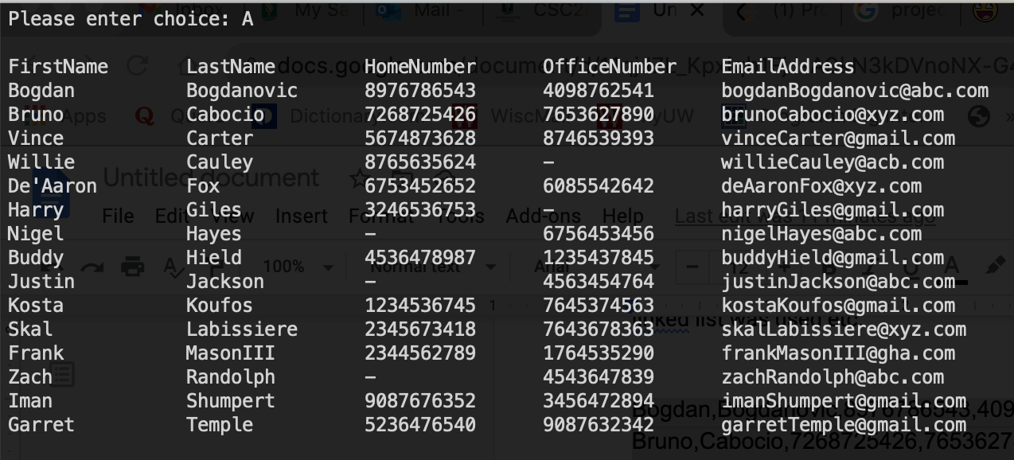

1. Sort by first name should also print list as above with first name in ascending order
2. Sort by last name should also print list as above with last name in ascending order
3. Search contact by first name

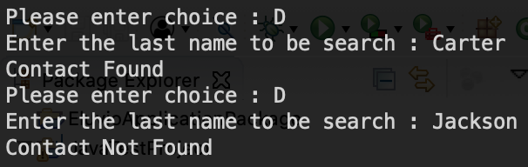

Q. Quit



Grading policies

Comments/ JavaDoc is necessary for each class

Indentation and good programming style

Data validation/reading from a file using try catch exception handling

Follow the assignment specifications as given